|  |  |
| --- | --- |
| **Team ID** | PNT2022TMID17579 |
| **Project Name** | IoT-Enabled Smart Farming Application |

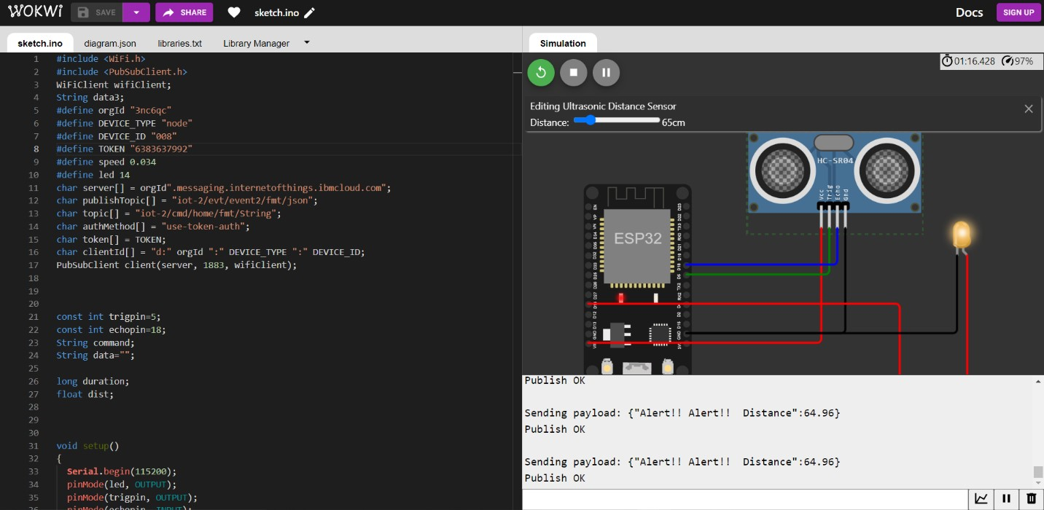

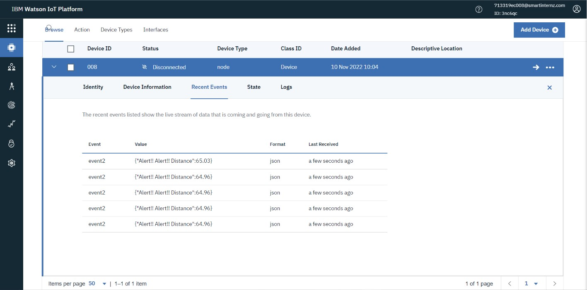

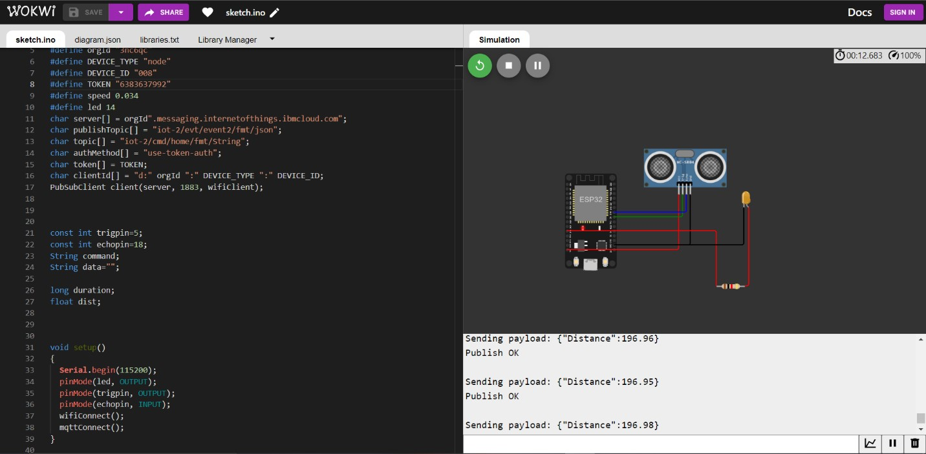

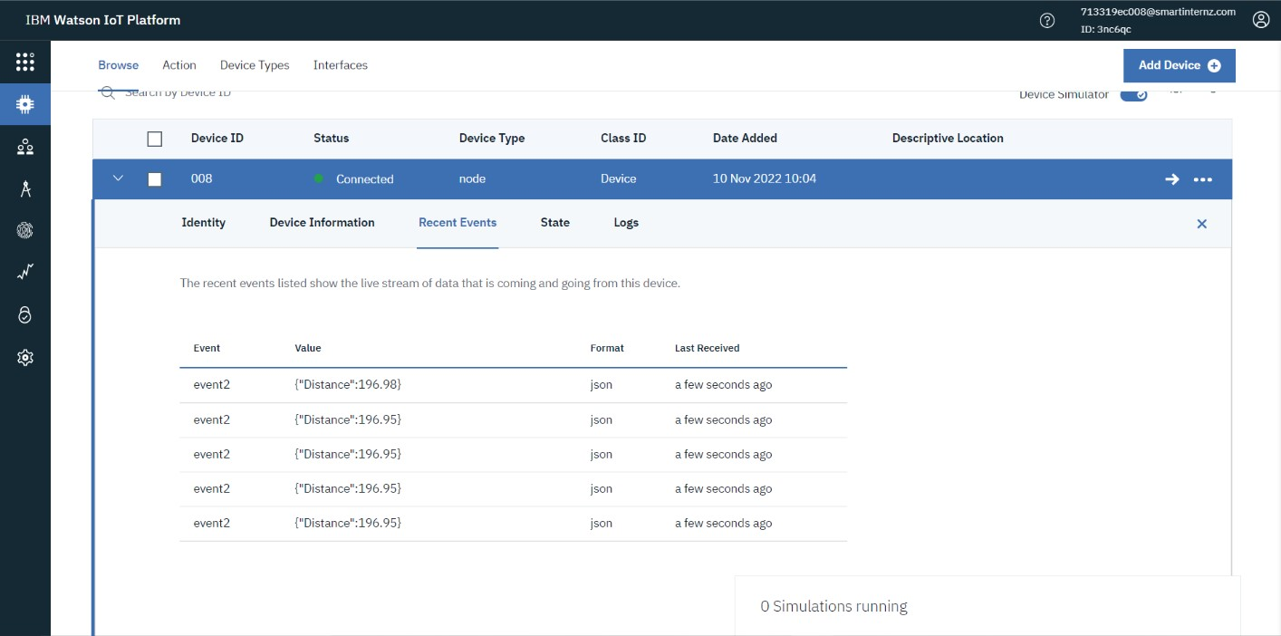

**WOKWI SHARE LINK:**

<https://wokwi.com/projects/347913412427121235>